

**Solution Approach Document: I&M Bank**

**Campaign Management**

**Version 1.3**



SOLUTION APPROACH

For

CAMPAIGN MANAGEMENT

By

Acidaes Solutions Pvt. Ltd.

Infospace, Tower 1, Ground Floor, Block B, Plot No. 2,

Sector 62, NOIDA - 201 309, UP, India;

Tel: (+91) 120 6784333; Fax: (+91) 120 6784334

Version: 1.3

Confidential and Proprietary

©Copyright 2011-2016, Acidaes Solutions Pvt. Ltd.

All Rights Reserved.

*The management team of Acidaes (the Company) has prepared this business document, and is being furnished to selected individuals within I&M Bank for the sole purpose of proposal evaluation, for sale of CRMNEXT and CRMNEXT services. This business document is confidential, and contains ideas, concepts, processes and other information that the Company considers proprietary. Readers are to treat the information contained herein as confidential and may not disseminate, copy or reproduce it in any form without the expressed written permission of the Company. ‘Acidaes’, ‘CRMNEXT, ‘Simplifying Technology’ and ‘smart.easy.complete’ is applied trademarks of Acidaes Solutions Pvt. Ltd. All other trademarks are the property of their respective owners.*

**Revision History**

|  |  |  |  |  |  |
| --- | --- | --- | --- | --- | --- |
| **Sr. No.** | **Date** | **Version** | **Description** | **Author** | **Reviewer** |
| 1 | 27-04-2018 | 1.0 | Document created |  |  |
| 2 | 27-04-2018 | 1.1 | Document Reviewed | Manish | Imtiyaz A |
| 3 | 24-05-2018 | 1.2 | Document updated post business discussion | Manish | Imtiyaz A |
| 4 | 29-05-2018 | 1.3 | Review comments of Kapil have been incorporated | Manish | Imtiyaz A |

Table of Contents

1. Objective 5

2. Introduction 5

3. Scope of document 5

4. Campaign Management Process 6

4.1 ASIS Process 6

4.1.1 ASIS Campaign Tools 6

4.1.2 Current process 6

4.1.3 Campaign Mediums 6

5. Proposed Solution 7

5.1 Campaign Workflow 8

5.1.1 Roles 8

5.1.2 Process Flow 9

5.2 Budget 15

5.3 Expenses (Operating cost) 15

5.4 Target Mailing List 15

5.5 Communication And Templates creation 15

5.6 Campaign Response 16

5.7 Actuals tracking 18

5.8 Fields for Campaign Management 19

5.9 Status Codes 22

5.10 Views 22

6. Assumptions 24

7. Annexure 24

# Objective

The objective is to implement the Campaign Management module in CRMNEXT. The users will create/track campaigns using the campaign management module.

The larger objective is to achieve sales effectiveness and efficiency in the organization through this implementation.

# Introduction

This is a solution approach document for implementing Campaign Management in CRMNEXT for I&M Bank. This document is prepared basis the business understanding provided by I&M Bank through meetings conducted to understand ASIS working.

# Scope of document

1. The document covers below processes
   1. Campaign Creation
   2. Campaign Approval
   3. Campaign Response capturing

# Campaign Management Process

## ASIS Process

As per the call with Business on 12th April the document (MOM) is stated below in the Annexure section.

### ASIS Campaign Tools

Currently the bank uses below tools for the Campaign management.

1. **Send Blaster** – Software to generate email body.
2. **Turbo SMTP** - It is paid service used by bank to send bulk emails.
3. **Email Me Form -** tool used to create online forms used for lead capturing and event registrations.
4. **Mantis -** Servicing software to log leads in form of cases when generated through digital web page
5. **Vision –** BI tool used to generate list of customers used for sending emails
   1. Analytics

### Current process

As a process when a request comes from product house (for e.g. Bancassurance dept.) for running a campaign and the content is provided to the social/digital team to generate email campaigns. Below sequence of steps are followed –

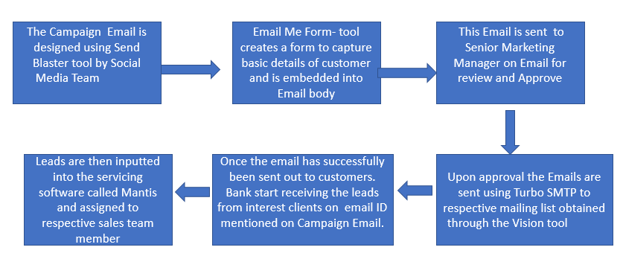

Figure 1 - Email campaign process

### Campaign Mediums

Mediums for campaigns are of types:

* 1. Email
  2. Digital Site-Leads are directed to company website
  3. Analytics campaigns
  4. Callcenter
     1. In this mode there is a call center number and the lead is manually created by Call Center Executive once the call is received by the customer.
     2. ~~Customers can also apply for products through Bank Website~~
     3. ~~Campaigns run by Analytics department~~
  5. Below medium will be provided as per scope of project
     1. Through Social media
     2. SMS Campaign
     3. Bank Website

# Proposed Solution

1. Using the Bank CRM, the tracking of campaign will happen at one place and the Bank will get a better idea of effectiveness of the campaign. Below is the basic flow of campaign process which will be available in CRMNEXT.
2. Marketing/Digital team of I&M bank will create and execute campaigns as a part of their marketing module on request of respective Product departments.
3. CRMNEXT will facilitate creation and execution of Campaigns, association of budgets and expenses related to the campaigns.
4. The functionality of below tools will remain unchanged as per the ASIS process
   1. Send Blaster
   2. Turbo SMTP
   3. Email Me Form
   4. Analytics
5. Proposed process flow:

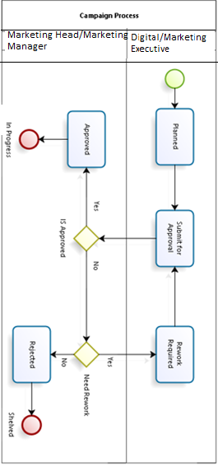

Figure 2 - Campaign Process

## Campaign Workflow

Campaign created in bank CRM and will move to different status codes for Campaign Approval.

### Roles

The list of roles are given below along with count and their responsibilities in brief:

|  |  |  |  |
| --- | --- | --- | --- |
| **Sr. No.** | **Abbreviation** | **Description** | **Access Rights** |
|  | DME | Digital/Marketing executive | 1. **Campaign**: Create, View 2. **Reports**: View |
|  | GM, P/M | General Manager, Products and Marketing | 1. **Campaign:** Approve, Modification, View 2. **Reports:** View |
|  | SMM | Senior Manager, Marketing | 1. **Campaign:**   Approve, Modification, View   1. **Reports:** View |
|  | PHM | Product house manager | 1. **Campaign:** View 2. **Reports:** View |

Table 1 - Roles

### Process Flow

1. Email Campaign workflow will contain of the following status codes:
   1. Planned: These will
   2. Submitted for Approval
   3. Rework Required
   4. Rejected
   5. Approved
2. The process will remain same for all types of Campaigns. Described it below using Email Campaigns for illustration.
3. **Planned**
   1. Product House Team Representative will be involved in proposing the Campaign for the related Product to Marketing Team.
   2. In CRM, DME will create the campaign and provide the Email template generated using “Send Blaster” for The Email Campaigns.
   3. He will then go to the Campaign object and will create a New Campaign. Refer the screenshot below for the same:

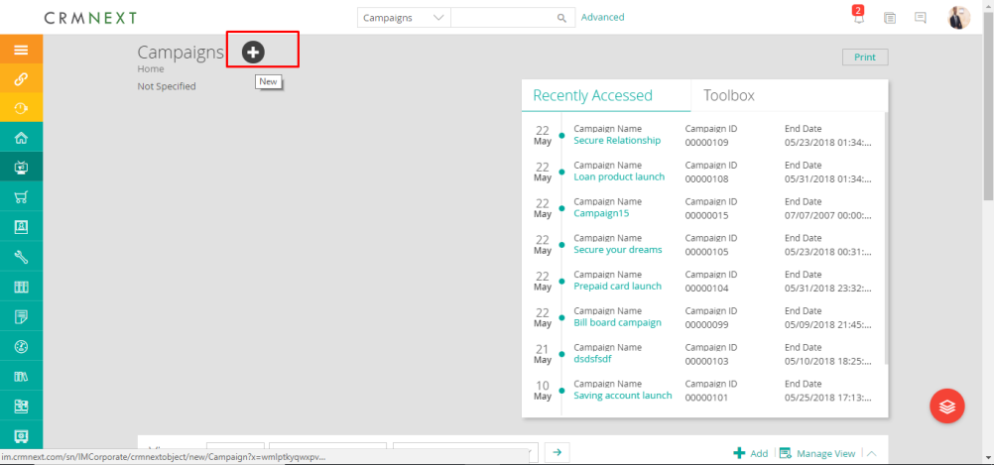

Figure 3 - Campaign Home Page

* 1. The creation layout will be displayed as shown below:

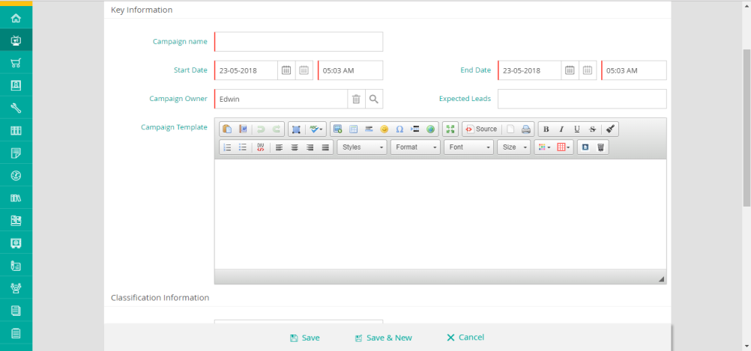

Figure 4 - Campaign Creation Page

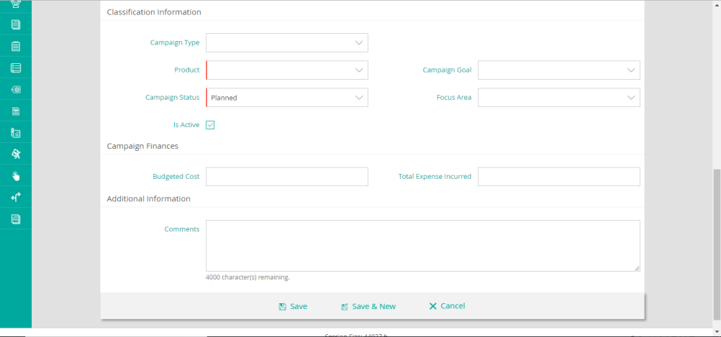

Figure 5 - Campaign Creation Page

* 1. On saving the Campaign, the values will be saved with the starting Date of the Campaign and the End Date of the Campaign.
  2. Attachment document (.pdf, .jpg) required to be attached will be uploaded by DME using the attachment section on the campaign detail page.
  3. The detailed View of the Campaign layout will be as displayed below:

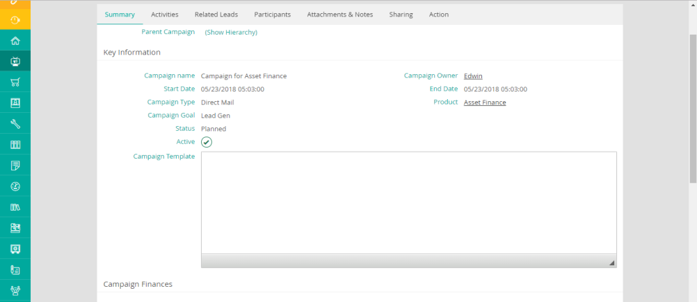

Figure 6 - Campaign Detail

1. **Submit For Approval**
   1. The DME will provide the related details on the Campaign screen such as
      1. Email Template
      2. ~~Generic Email Address which will receive response of “Email Me Form” – Mandatory Field~~
      3. Budget– Mandatory Field
      4. Incurred Expenses
      5. Campaign Type - Mandatory Field
         1. Offline
         2. Digital
         3. Email
         4. Referrals
         5. SMS – Provided, it is in project scope.
      6. Product – Mandatory Field.
      7. Please see the complete field list under section “Fields for Campaign”
      8. DME will now select the approver as either SMH or MM manually and send it for their approval by clicking on the “Submit For Approval” button.

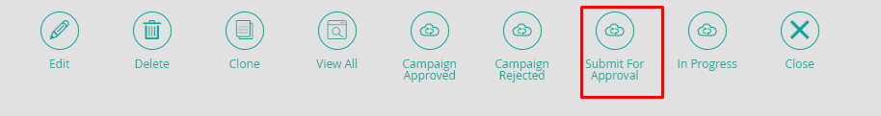

Figure 7 - Campaign Action Buttons

* 1. On clicking it, a pop-up will open to assign it to the corresponding role for his/her approval. Refer to the screenshot below:

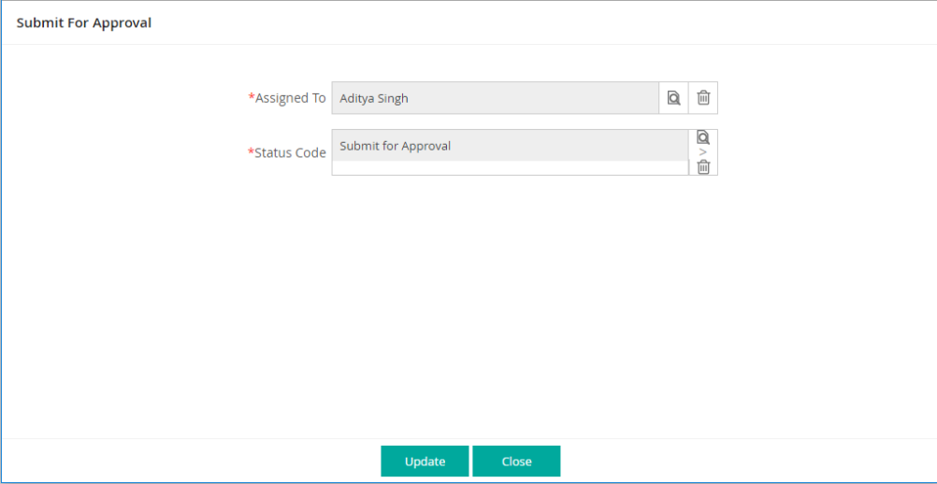

Figure 8 - Approval Page

* 1. The campaign will be at status code “Submit For Approval”. The campaigns sent for approval will appear in Campaign view to SMH or MM for the approval.



1. **Rework Required**
   1. The SMH or MM will then review the campaign and send it for either
      1. Rework Required or
      2. Approve.
   2. He will also have option to reject the campaign with below status code
      1. Rejected

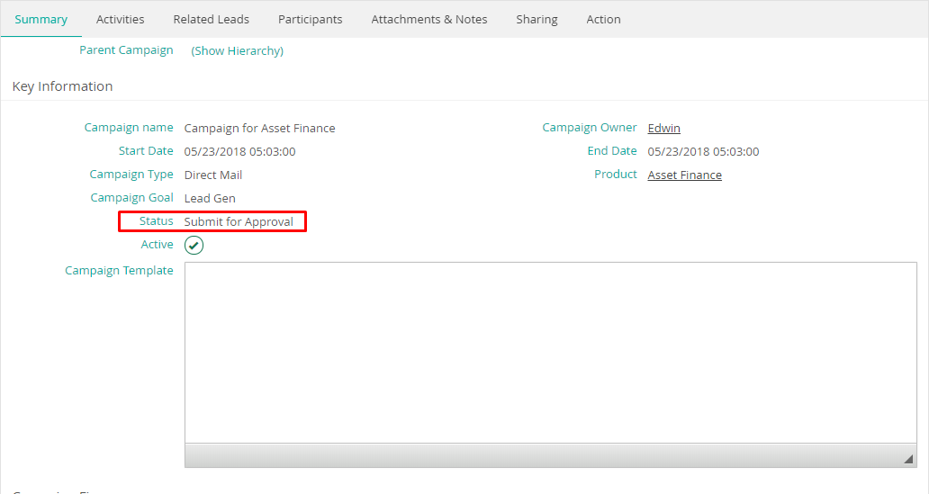

Figure 9 - Campaign Submit for approval

* 1. On Rework required status code, the campaign will go back to the originator with specific comments for the action needed.
  2. Once the originator reworks on the campaign then the campaign will again move back to the status code “Submit for Approval” and further action will be performed on it.

1. **Rejected**
   1. The approver will have the right to reject the campaign by providing specific comments.
   2. No further action will be performed on the campaign.
2. **Approved**
   1. Once the campaign is approved the campaign will be active and leads can be tagged to that campaign on the lead creation page.
   2. Refer the screenshot below for reference.

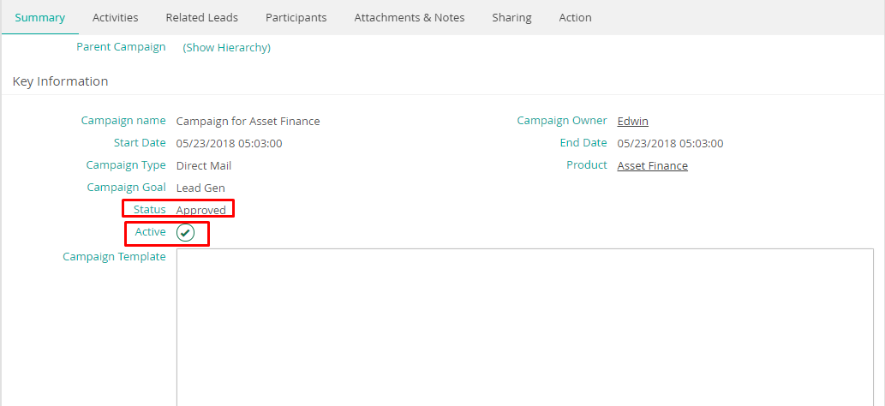

Figure 10 - Campaign Approved

1. **In Progress**
   1. Once the campaign is approved by Approver (SMH or MM), DME manager will receive an alert/SMS listing approval of campaign has been received.
   2. Post this DME will run the campaign as per the ASIS process and change the status to “In Progress”.­­
   3. At this status code, the mailing list and email sending to the identified customers will be handled in the “Send Blaster” using “Email Me Form” and “Turbo SMTP” as part of the ASIS process.
      1. Post sending of emails, the campaign response will be captured. For details refer Campaign Response of this document.
      2. Once the Campaign response is captured and timeline of campaign has been completed, DME (initiator of campaign) will change the status to “**Complete**” basis the success/result of the campaign.
2. Analytics Campaign
   1. The process flow of Campaign Planning, Approval, Rejection and In process will remain same as that of Email campaigns except email will be send through “Python” scripts and clicked/interested entries are tracked by directing the user control to separate Web Page.
   2. Once the lead is tracked as interested in Vision, the leads will be generated in Bank CRM by calling CRM webservice by Vision/Cron Job and providing the Campaign Code.
   3. The lead will be processed as normal lead in “Bank CRM”.

## Budget

1. Budget is the finance available for organizing a campaign.
2. Budgets will be allocated against each campaign in Bank CRM.
3. Typically, such budgets will be part of the overall budget allocated to the Respective Dept.
4. Budget amount will be manually added in the budget field provided while designing the campaign

## Expenses (Operating cost)

1. Expense is the cost incurred for organizing the campaign.
2. Expense incurred will be manually entered once the campaign has been executed.

## Target Mailing List(Applicable only for Email Campaign)

1. The mailing List will be maintained in “Send Blaster” tool for the identified customers for the email Campaigns.
2. The mailing List will be maintained in “Vision” for the identified customers for the analytics Campaigns.

## Communication And Templates creation

1. Email:
   1. Campaign ad or customer specific data will be sent through email using “Send Blaster”, “Email Me Form” & “Turbo SMTP”.
2. Analytics:
   1. Campaign ad or customer specific data will be sent through email using “Python Script”.
3. Digital Campaign
   1. Users will continue to opt for products through Bank’s Digital Landing Page of Web site.
4. Website page of Products and services
   1. Similar to digital Campaign, Users will be directed to specific products web landing page.
5. Other Campaigns(offline Campaign)
   1. User can continue to make a call at the Call Center and will show his inclination to opt for Campaign product.

## Campaign Response

1. Lead creation
   1. Campaign based lead capture will be done in CRMNEXT.
   2. Leads will be captured through following modes:
      1. Manual: For manual lead creation, campaign name will be necessarily captured with lead data. This will be applicable in case of Branch Walk-In as well as Customer approaching contact center and providing the campaign details.
      2. Email: Based on response of customer to a specific email id –through “Interested Button” in Email Body, lead will be created in CRMNEXT.
         1. The response of email will be captured through “Email Syndication” feature of CRMNEXT integrated with “Generic Emails” used by product houses/Segments.
         2. If the email is coming from registered user email id, then the lead will be tagged to customer with registered email id and subsequently assigned to “Sales Team Executive” automatically for the product associated with Campaign.
         3. In case the customer is not identified, the lead will remain in “suspense view”, where “Sales Team Executive” will pick-up the lead and will provide relevant information about lead in “Bank CRM” post interaction with prospective lead/Customer. Based on information received the lead will continue to be assigned to CSO/RM for further processing.
            1. This will be mode of response capture in case of

Email received through Email Campaigns

Email received through Digital Media Campaigns

Email received through Website Campaigns

* + - 1. Email Subject line will contain the product details. Same will hold true even in case of multiple products (associated with Campaign).
         1. The Email Subject and body will have place holders for Product code and Campaign Codes.
         2. Subject line examples

Re: Campaign: YS001 and Product: Malaika

Re: Campaign: YS001

Re: Product: Malaika

* + - * 1. Email Body examples

Campaign: YS001

Product: Malaika

* + 1. Mobile Banking/Internet Banking/Analytics/Generic Landing Page:
       1. The lead will be created in CRMNEXT via web service.
          1. The source system will be using the CRMNEXT webservice to create lead in CRMNEXT. These systems should pass below details through web service

Customer Name

Product Selected by Customer

Campaign Code

CIF

Mobile Number

Email Address

Location

* + - * 1. In case above details, are not available, Lead will be created and put into Suspense bucket for Sales team for to identify and taken\ action further till lead closure.

Technical Integration details will be covered through separate technical document.

* + - * 1. For further processing of leads refer the “Individual Sales/Leads Solution Approach Document”.
    1. Manual Leads generated by Sales/Marketing Team for Non-Campaign Products
       1. The Sales team will be provided by rights to create new lead for Non-Campaign Products
       2. Which will be self-assigned to them for further processing
       3. However, if they want to re-assign to other Users/Branch Users they can do the same using the re-assignment functionality provided in leads. For more details you can refer the “Individual Sales/Leads Solution Approach Document”.
  1. The Leads will also have provision to select the following “Sub Channel” against Campaign to track the return on investment on medium of Campaign
  2. Sub Channels will be added in lead page against Campaign Type through Campaign Code
     1. TV Ads
     2. Radio Ads
     3. TV Ads
     4. Print Ads
     5. Magazines
     6. Flyers/Posters
     7. In -branch Screens
     8. Emails
     9. Referrals
     10. Call
     11. Branch walk-in
     12. Below channels will be included provided they are project scope
         1. Google
         2. Face Book
         3. Linked In
         4. Twitter
         5. Instagram
         6. Youtube
         7. ATM Screens

## Actuals tracking

1. Once the campaign has been executed, the actuals of leads created and converted on the campaign detail page itself. Also, all the related leads created through that campaign can be seen in the detail page of that campaign. Below screenshots can be used for reference –

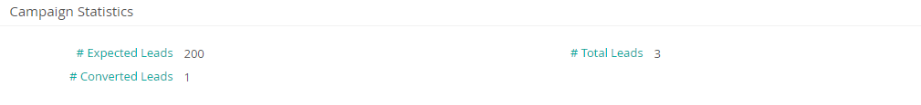

Figure 11 Campaign Statistics on Detail Page

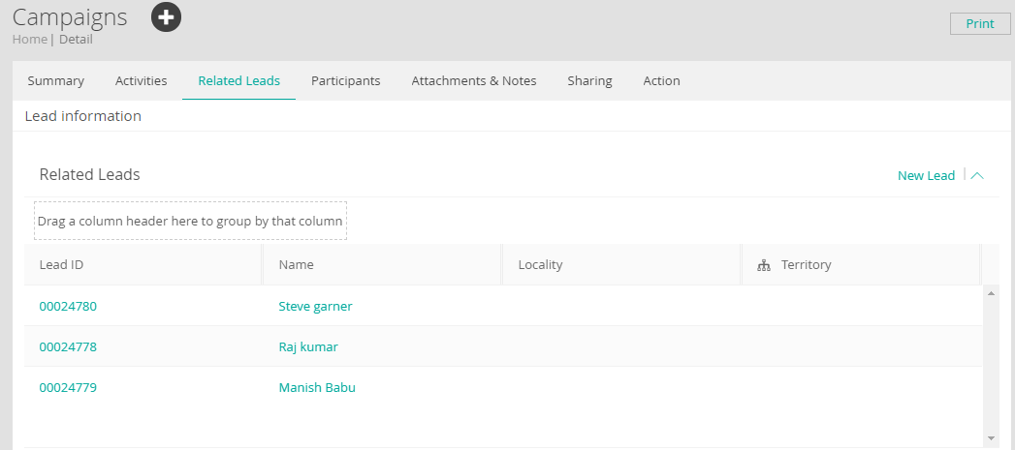

Figure 12 Related Leads for that Campaign

## Fields for Campaign Management

1. The field list for campaign management is as follows: -



1. Fields

|  |  |  |  |  |  |  |  |  |  |
| --- | --- | --- | --- | --- | --- | --- | --- | --- | --- |
| **S. No.** | **Section** | **Field Name** | **Field Description** | **Values** | **Data type** | **Field Size** | **Mandatory** | **Comments** | **Validation** |
| 1 | Key Information | Campaign Name | Name of the Campaign |  | Alphanumeric | 128 | Y |  |  |
| 2 | Campaign Id | System generated Id |  | Alphanumeric | 4 | Auto | Unique identifier for campaign |  |
| 3 | Start Date | Campaign Start Date |  | DATE |  | Y |  |  |
| 4 | End Date | Campaign End Date |  | DATE |  | Y |  |  |
| 5 | Campaign Code | Unique Campaign Code to identify a particular Campaign. |  | Alphanumeric | 8 | Y |  | It needs to be Unique in CRM system |
| 6 | Campaign Owner | Originator of the Campaign |  |  |  | Y | Campaign Creator Name will come by default |  |
| 7 | Campaign Status Code | Process flow stage of Campaign | 1. Planned 2. Submit For Approval 3.Approved 4.Rework Required 5.Rejected 6. In Progress 7. Completed | Picker |  |  |  |  |
| 8 | Classification Information | Product | Product for the Campaign | Values of product(stored in the system) | Picker |  | Y | One product at a time can be selected only |  |
| 9 | Campaign Type | Multipicker | 1. Offline 2. Digital 3. Email 4. Referrals  5. SMS 6. Call | Multi Picker |  |  |  |  |
|  | Campaign Channel | Multipicker | 1 TV Ads 2. Radio Ads 3.Print Ads 4. Magazines 5.Flyers/Posters 6.Google 7.Facebook 8.Linkedin 9.Twitter 10.Instagram 11.Youtube 12 ATM screens 13 In-branch Screens |  |  |  |  |  |
| 10 | Campaign Template |  |  | Template Picker |  |  |  |  |
| 11 | Is Active | To Identify Active Campaigns |  | Y/N |  |  |  |  |
| 12 | Campaign Estimates | Expected Lead Count | Best judged estimated Lead Counts |  | Numeric(6) |  |  |  |  |
| 13 | Comments | Any free text notes to be provided by Campaign Originator. |  | Alphanumeric | 1024 |  |  |  |
| 14 | Budgeted Cost | Budgeted Cost of Campaign |  | Amount |  | Y |  |  |
| 15 | Leads Statistics | Total Expense Incurred | Actual Expense incurred |  | Amount |  |  |  |  |
| 16 | Leads Captuted | Total Number of Leads Captured for the Campaign |  | Numeric(8) |  | Auto at EOD |  |  |
| 17 | Leads Converted | Total Number of Leads Converted for the Campaign |  | Numeric(8) |  | Auto at EOD |  |  |
| 18 | Leads Rejected | Total Number of Leads Rejected for the Campaign |  | Numeric(8) |  | Auto at EOD |  |  |
| 19 | Leads Not Interested | Total Number of Leads Not Interested in Campaign |  | Numeric(8) |  | Auto at EOD |  |  |
| 20 | Leads In progress | Total number of Pending Leads for the Campaign |  | Numeric(8) |  | Auto at EOD |  |  |

## Status Codes

|  |  |  |
| --- | --- | --- |
| **Sr. No.** | **Name of the Status** | **Description** |
| 1 | Planned | This describes that currently the campaign is in Planning phase |
| 2 | Submit for Approval | This describes that campaign has been submitted by Product /Marketing Manager and has been sent for marketing head approval |
| 3 | Approved | This describes that Campaign has been Approved |
| 4 | In Progress | This describes the Campaign is being approved and now the work is started on same. |
| 5 | Rejected | This describes that Campaign has been Rejected |
| 6 | Rework Required | This describes that Campaign has been sent for rework |

**Table 2 List of status codes**

## Views

1. The list of views that will be available are listed in the table below:

| **Sr. No.** | **Name of the View** | **Description** |
| --- | --- | --- |
|  | Active Campaigns | This will list all the active campaigns in the system and will be visible to the Owner of the Campaign and the seniors in the hierarchy above. |
|  | Planned Campaigns | This will list all the planned campaigns in the system and will be visible to the Owner of the Campaign and the seniors in the hierarchy above. |
|  | Submit for Approval | This will list all the campaigns in the system which are being sent for Approval and will be visible to the campaign approver for his action to approve the same. |
|  | Approved campaign | This will list all the Approved campaigns in the system and will be visible to the Owner of the Campaign and the seniors in the hierarchy above. |
|  | In Progress Campaign | This will list all the In-Progress campaigns in the system and will be visible to the Owner of the Campaign and the seniors in the hierarchy above. |
|  | Completed Campaigns | This will list all the completed campaigns in the system and will be visible to the Owner of the Campaign and the seniors in the hierarchy above. |

**Table 3 List of Views**

1. Below is illustrative screen for showcasing the views on the end user screen –

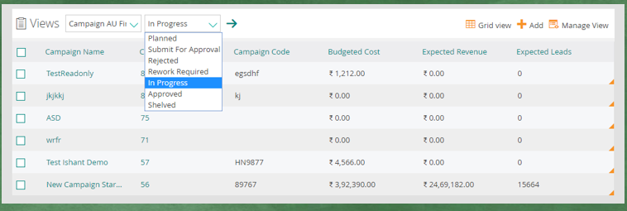

Figure 11 Illustrative Views

# Assumptions

1. There will be no separate process for Budgets and Expenses.
2. The process for campaign management will remain same for corporate as well as retail customers.
3. The functionality of “Send Blaster”, “Turbo SMTP”, “Email Me Form”, “Python Script”, “Vision Cron Job” will remain ASIS and “Bank CRM” will be mainly used to keep the email response solution common for all types of Campaigns tracked through generic email ids.
   1. Hence, there will be no triggering of mails from CRMNEXT, same will be handled as done currently through Send Blaster tool.
4. Campaign module will not be available on mobile devices, though leads referencing to defined campaigns will be created on mobile devices.
5. No Multilingual support will be provided as it depends on device capability and service provider’s ability to support the same.

# Annexure

